MyHealth Portal

# 1. Abstract

MyHealth Portal is a project that was built by Nathan Zander and Hunter Casteel for CS-360 Database Systems. It was designed to support two types of users: doctors and their patients. Doctors will be able to use the MyHealth Portal in order to view information on patients, as well as edit their information. Patients will be able to sign themselves up to the portal, and they will be able to view all information that the doctor puts into their profile. All of this information is stored inside an external MySQL database, which allows all parties to view and edit the most up-to-date information.

# 2. Introduction

This paper contains an overview of the entire software. First we will take a look at the database and how it is laid out, describing the tables and what they are used for. We will also discuss the web interface, which has two sides to it, the doctor side and the patient side. The patient side offers the ability to search and change insurance plans, order products, and schedule services or tests. They also have the ability to look at diagnoses, prescriptions, and bills that the doctor has created for them. Finally, there is a Report tab that allows them to look over all this information in one place. The doctor portal offers a different suite of features. Here you can look up your upcoming appointments, and create or view diagnoses, prescriptions, and bills. If you would like to look up all the information about a single patient, you can do that under the report tab. We will be discussing all of these functions in detail.

# 3. Technology Used in Development

In order to create such a large and versatile software, we made use of a wide array of technologies. The most central and critical technology we used was a MySQL database. This key piece of technology houses and updates all the information seen in the application. It manages tables as well as generates new keys for the rows as we add them. In order to interface with the database, we used an interface known as phpMyAdmin, which is a database administrator tool that allows us to view and modify information easily. We can also communicate with database directly by making use of a language called SQL, which is a language specifically structured to be efficient at querying databases, as well as being fairly human readable. In order to create the dummy data that we used in creating and testing of the MyHealth Portal, we used an online tool at filldb.info, which is a site that can fill up an entire database with meaningless strings and numbers. Quite useful compared to writing out hundreds of rows of data for testing by hand. Once our test data was in place, we could use it to verify that data was being accurately passed back and forth.

Our web interface makes use of still other technologies. The MyHealth interface was primarily built with a language called PHP. PHP is a language commonly used in web development. It allows you to place a <? php ?> tag in the middle of the html, allowing you to add logic directly to the page, sometimes even using the echo command to dynamically add html to the dom, based on certain conditions. PHP was not our first choice as developers, however with the database connection set up for us on the class server with PHP, attempting to create our own database connection using some other language may not have been preferrable. We were able to make use of the PHP connection, though, by passing SQL statements to the database through the connection that was provided. This proved essential for constructing the page based on information received from the database. It is how all data was sent and received from the database. Lastly, in addition to PHP and html, we used CSS to style the pages in a professional way, ensuring that our interface was comfortable and friendly to use.

# 4. The Database

Our database has many tables, as would be expected of a large application. These tables are all used for some aspect of our software, however if you were to build the software into an even larger interface, these tables are readymade to do so. First, and most critically, are the Patients and Doctors tables. These tables are central to the database and act as the key to many other tables.

*Patients Table*

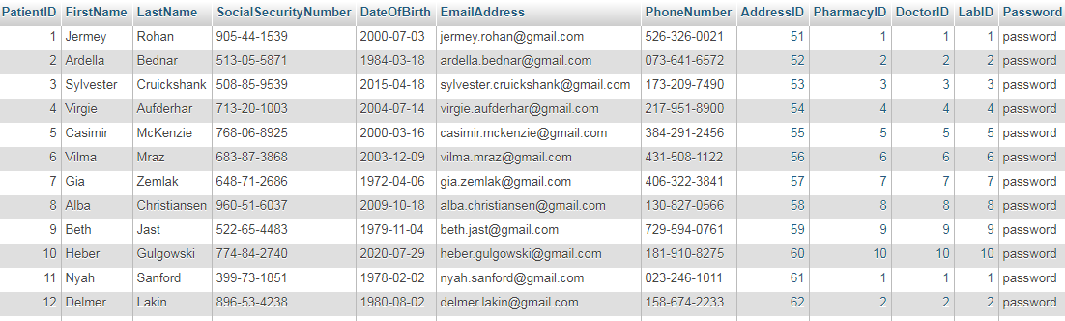

*Doctors Table*

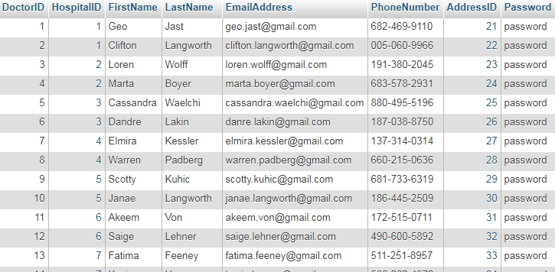

These contain information like names, phone numbers, social security numbers, etc. It also contains their login information such as email and password, and so these tables are referenced when login attempts are made. Our passwords are currently stored in plaintext, however if we had additional time and money we could implement further security procedures, such as storing only hashed passwords in the database, to be compared with the hashed version of whatever the user typed in.

Next, you have the Pharmacies, Labs, and Hospitals tables. These tables are used to describe fairly similar entities with different roles in the MyHealth software. Pharmacies are used to determine where a prescription is sent, Labs are used to order tests performed, and hospitals are used to determine where doctors are located.

*Pharmacies Table*

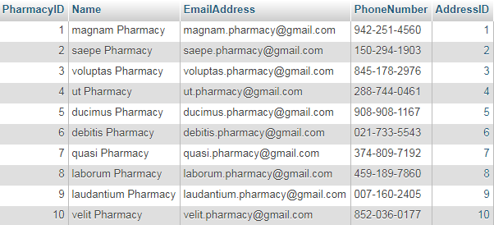

*Labs Table*

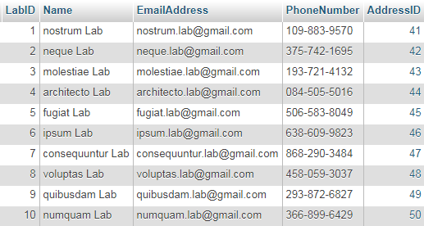

*Hospitals Table*

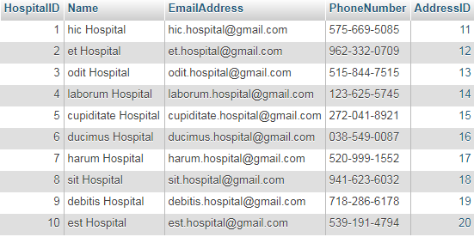

InsurancePlans is a table that allows patients to search all the available insurance plans offered by insurance companies. Patients will be able to pick and choose which insurance plan suits them the best. A table called PatientsInsurancePlansAndCoverage keeps track of the many-to-many relationship that patients have with insurance plans.

*InsurancePlans Table*

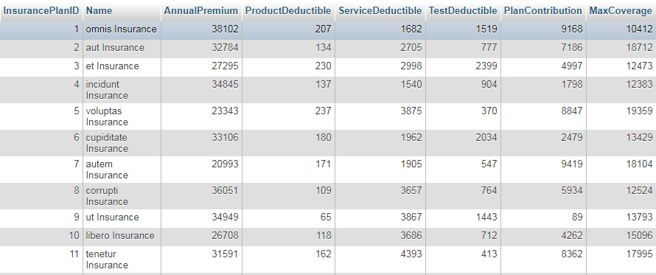

*PatientInsurancePlansAndCoverage Table*

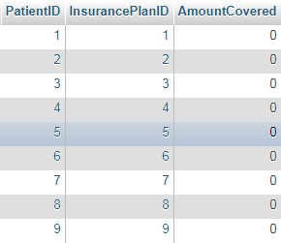

Diagnoses is the table of all accepted and coded diagnoses. The doctor will be able to choose from this list when diagnosing a patient. The table PatientsDiagnoses, on the other hand, keeps track of which patients have been diagnosed, as well as the doctor’s notes that were written when they were diagnosed.

*Diagnoses Table*

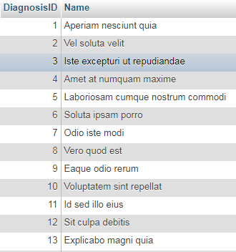

*PatientsDiagnoses Table*

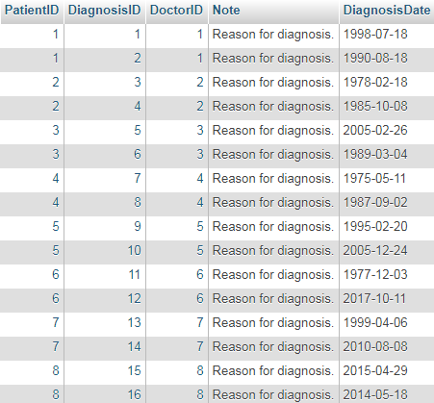

Services is the table of all offered services. It is used in the creation of bills, and the scheduling of new services. When a patient wants to schedule a service, they can create an appointment, which will be added to the ServiceAppointments table. The doctor can also bill for services performed, and these will be stored in the ServiceBills table.

*Services Table*

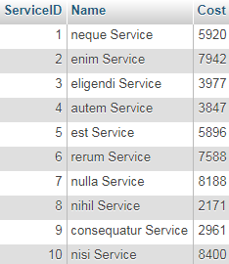

*ServiceAppointments Table*

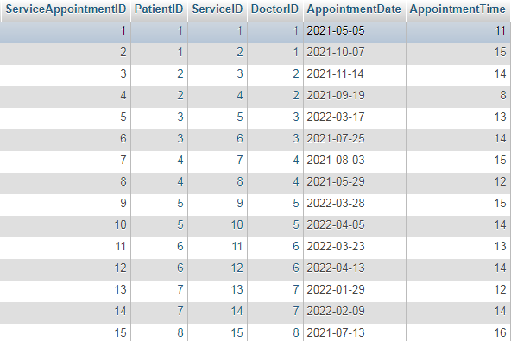

*ServiceBills Table*

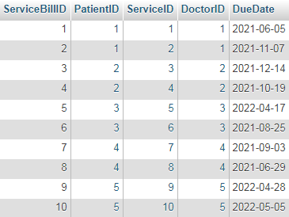

The Products table is used to store available prescriptions and products that the doctor may prescribe for a patient. When the doctor orders a product for a patient, it is listed under the Prescriptions tab by use of the PatientsPrescriptions table.

*Products Table*

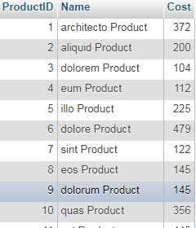

*PatientsPrescriptions Table*

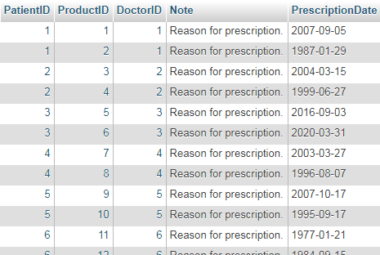

The Addresses table is used as a central location for all addresses in the database. This includes addresses of Labs, Hospitals, Patients, and Doctors. When new patients register their information, their address is added to this table and the ID for the corresponding address is added to the Patients table. This is a way of having addresses available for all these entities, without having to store that information directly on the other tables.

*Addresses Table*

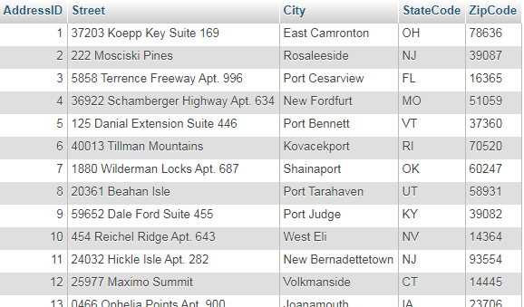

In order to generate this database quickly and efficiently, we have written an SQL script that allows the entire database to be generated with a single import. This also allows us to modify critical parts of the database easily, because all it requires is a modification to the SQL file and the new changes can be built into a brand new database. The file is quite long, as to be expected of a big database, and has a series of CREATE TABLE statements, followed by a series of INSERT INTO statements with the appropriate dummy data to get the database started. This has proved highly useful during testing and development.

*A small excerpt from our database.sql script*

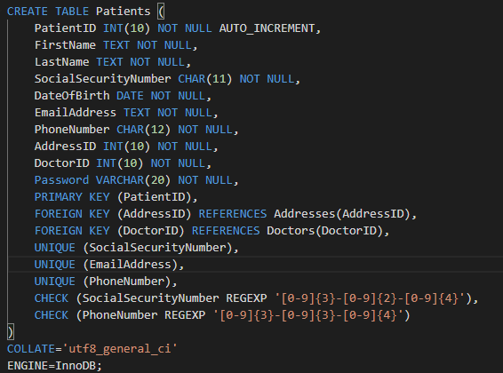

# 5. The Landing Page

Let’s take a closer look at the web interface that the MyHealth Portal uses. Upon first arriving at the website, you will be greeted with a login page. From here, you are required to enter in your email and password. Your email is how it differentiates between the patient and doctor. If the email and password are found to match on the Patients table, access is granted to the patient portal. If the email and password match an entry on the Doctors table, you will be logged in to the doctor portal. If neither is found, you get an error message informing you that your login attempt failed.

*The login screen of the MyHealth Portal*

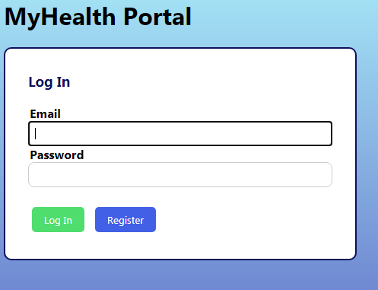

*A failed login attempt*

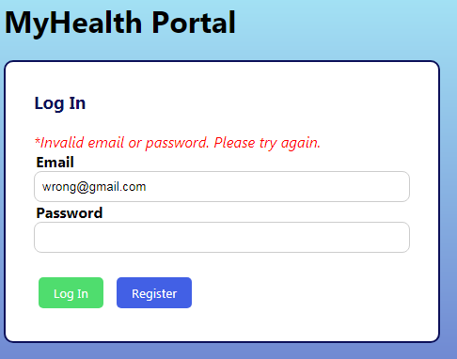

Alternatively, if you don’t have an account yet, you can click “Register”. Here you will have fields where you can enter your name, social security number, date of birth, email, password, and other forms of information that you can see here. If all information has been entered correctly, you will be taken back the login page. From here you can enter in the email and password that you just registered, and use it to log in to the patient portal. Your patient profile will be empty except for your account information, however the doctor will be able to view your profile now and start filling it out with the pertinent medical information. The register page also features careful error checking, ensuring that all fields are present and valid, and notifying you which one is the problem if they are not.

*The Register page*

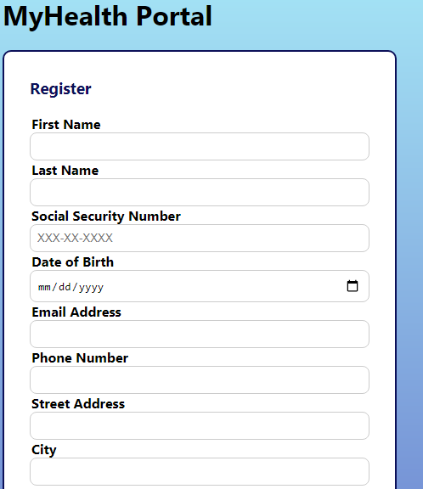

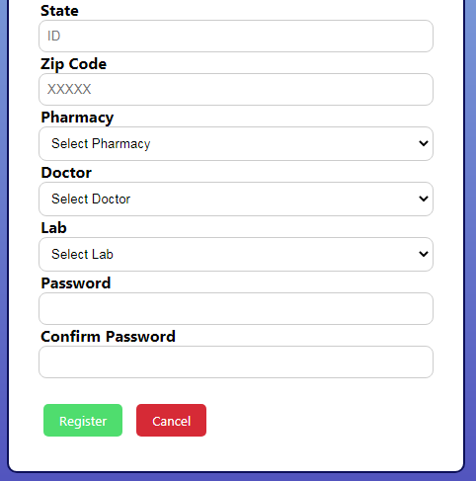

# 6. The Patient Portal

As soon as you log in to the MyHealth portal with valid patient credentials, you will be taken to the homepage of the patient portal. “Patient Portal” will be displayed in the corner. Below this is our navigation bar, which enables you to travel to all different pages of the portal at any time. The homepage primarily consists of your general account information, including your name, social security, address, and pretty much all of the information that was required to register. Below this you will also be able to see the details for the insurance plan(s) that you are signed up for. You can cancel insurance plans by pressing the red “Cancel” button on the insurance plan you wish to get rid of. If you want to sign up for new insurance plans, you can go to the Insurance tab. All the way at the end of the navigation bar, the Log Out tab will immediately log you out of the patient portal and prompt you to log in again.

*The Patient portal homepage*

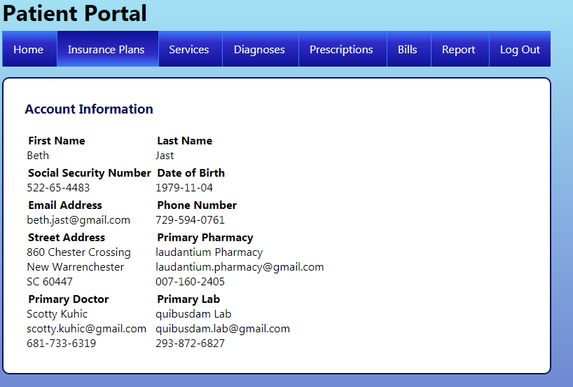

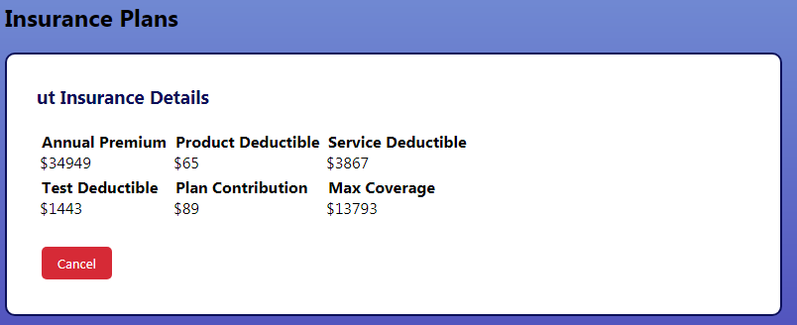

The Insurance Plans tab is next on the navigation bar. It allows you to browse potential insurance plans for a plan that fits you best, and sign up for a new one. You can search for insurance plans based on annual premium, product deductible, service deductible, test deductible, plan contribution, and maximum coverage. You can search for insurance plans by entering a maximum or a minimum on any or all of these values. Leaving fields blank will default to searching for all plans. Once you have your criteria entered, press the Browse button to begin the search and it will return a list of all available insurance plans. If you see one that looks good to you, you can press the “Signup” button and that insurance will be added to your overall plan.

*The Insurance Plans tab*

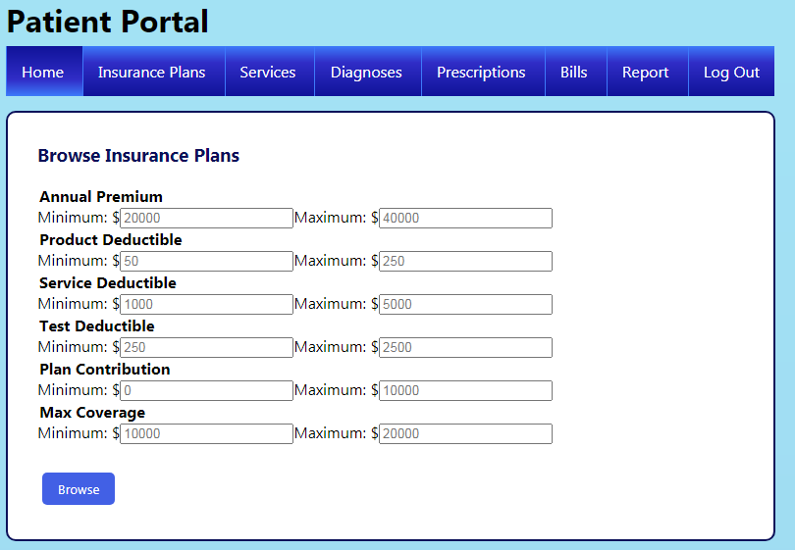

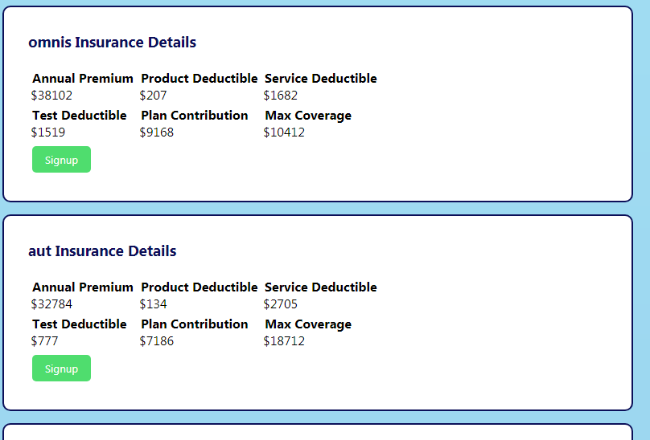

The services tab allows you to schedule a service with a doctor of your choice. You can select from existing services with the Service dropdown, and choose a doctor from the Doctor dropdown. You can also input a date and time, with the time in the dropdown giving you options for any hour that the doctor is scheduled to work. Below the box for scheduling services, you can see all of your existing service appointments that are coming up.

*The Services tab*

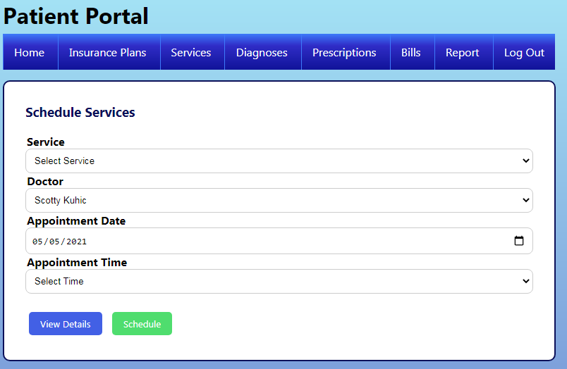

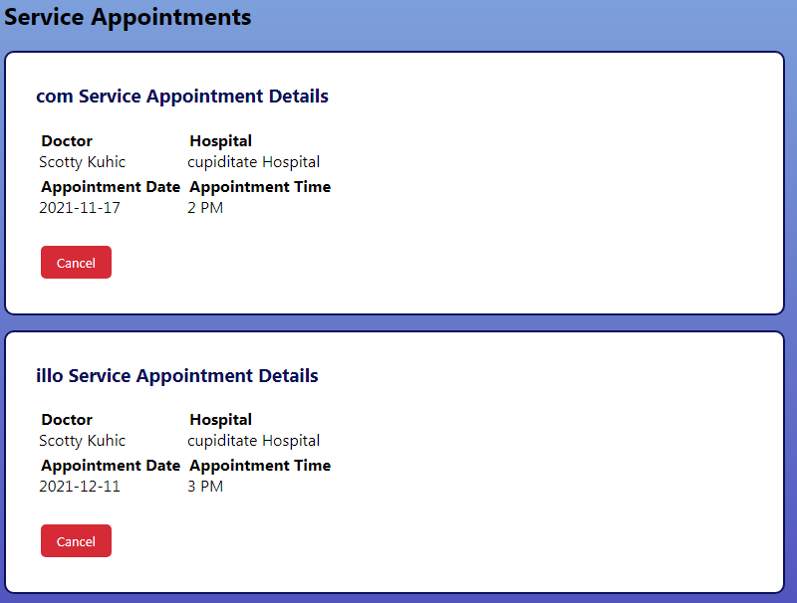

The Diagnoses tab allows you to view all diagnoses that the doctor has written for you. Each diagnosis has with it a doctor’s note and the date it was diagnosed. It also includes information about the doctor who wrote the diagnosis.

*The Diagnoses tab*

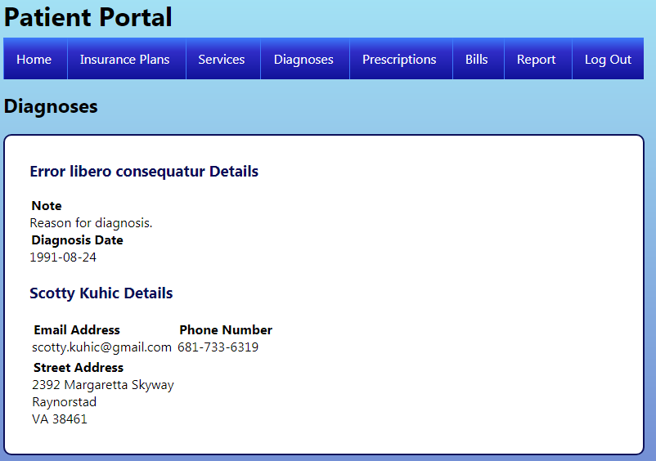

The Prescriptions tab operates in much the same way as the diagnoses tab. It will allow you to see all existing prescriptions that the doctor has created for you. It also includes a doctor’s note and date it was prescribed, as well as information about the doctor who prescribed it.

*The Prescriptions tab*

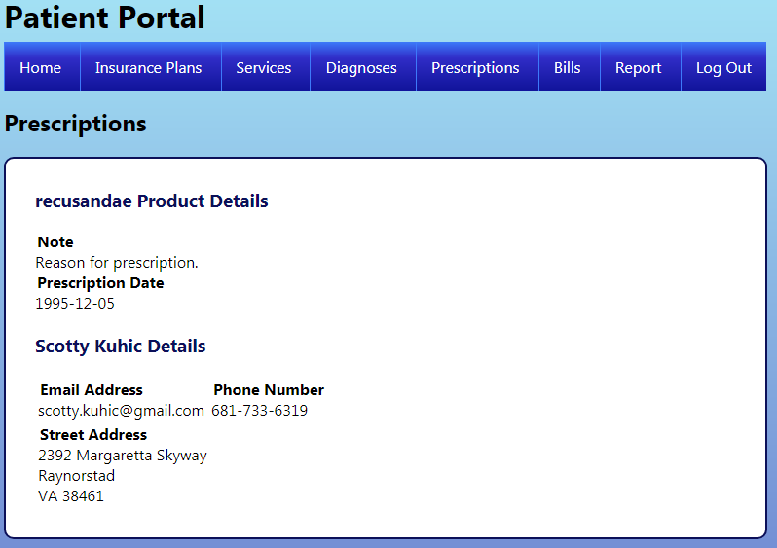

The Bills tab allows you to view and pay for all services billed out by the doctor. Each billing item informs you the name of the service, cost of the service, which doctor performed it, and when the bill is due. You can also press the “Pay” button to mark the bill as paid, although this would definitely be more than a one-step process if our application was able to process transactions.

*The Bills tab*

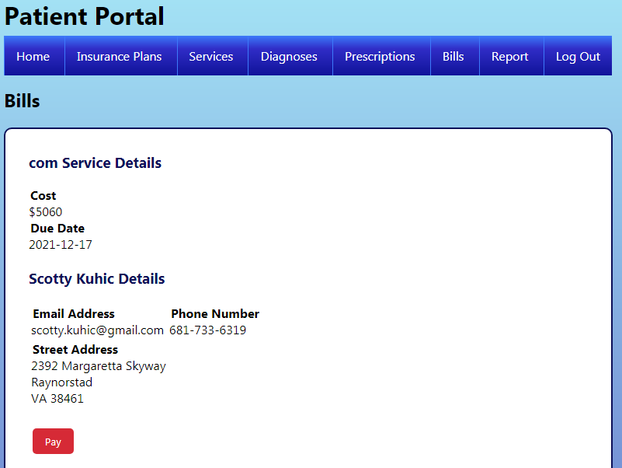

The last feature of the patient portal is the Report tab. This tab allows you to view all of the information about your account at once. You can see your prescriptions and your appointments and your bills all in one place.

*The Report tab*

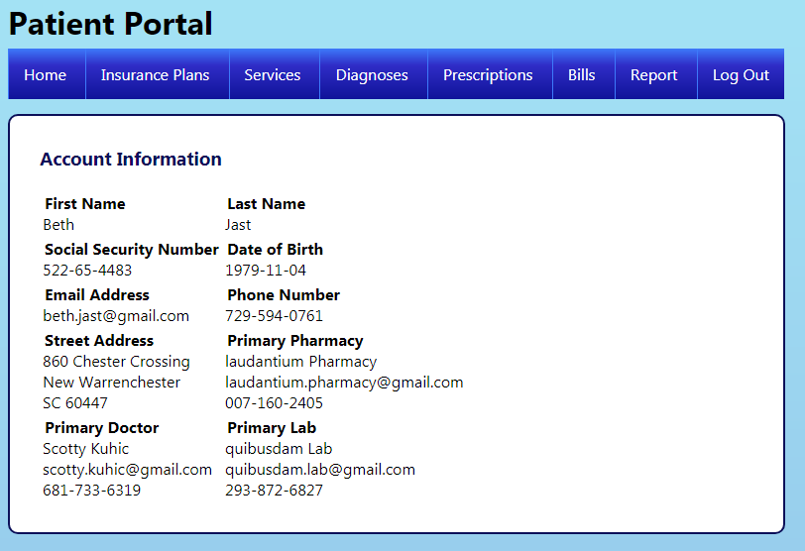

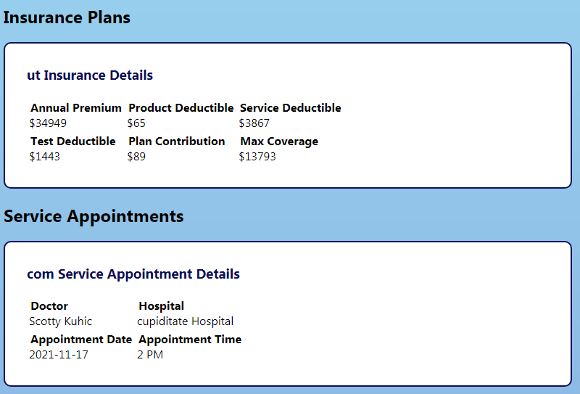

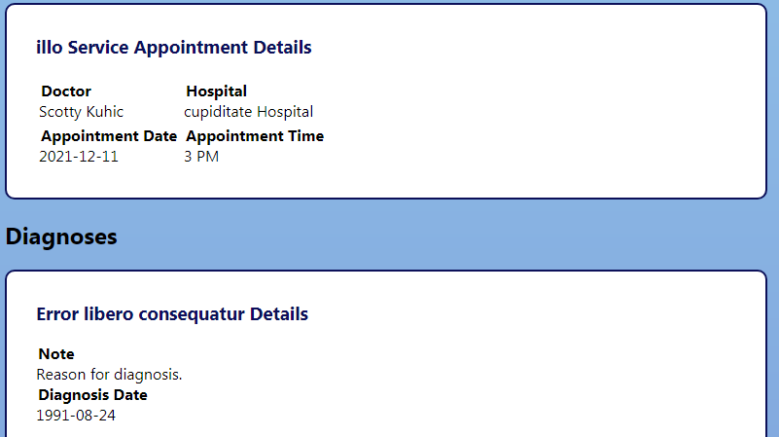

*The Report tab continues on for some time and has further information, including prescriptions and bills.*

# 7. The Doctor Portal

Logging in to the MyHealth portal using valid doctor credentials will bring you to the doctor portal. The words “Doctor Portal” in the top left indicate that you are in fact using the doctor role and will have doctor level permissions. Below that is the navigation bar for the doctor. This navigation bar is slightly different from the patient’s navigation bar and includes Home, Appointments, Diagnoses, Prescriptions, Bills, Report, and Log Out. Home is the tab that you start off at immediately after logging in. From here, you can see all of the account information for the doctor. Pressing Log Out on the right side of the navigation bar will log you out of the doctor portal and send you back to the login screen.

*The homepage of the doctor portal*

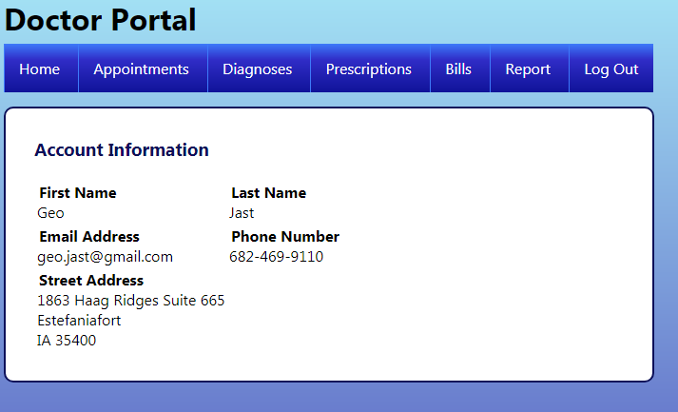

The Appointments tab allows a doctor to see what appointments he has for a given day. Each appointment will be displayed with the name of the service, name of the patient, and what time the doctor will be seeing them. Should the doctor also wish to cancel an appointment, he can do so by clicking the “Cancel” button directly on the appointment.

*The Appointments tab of the doctor portal*

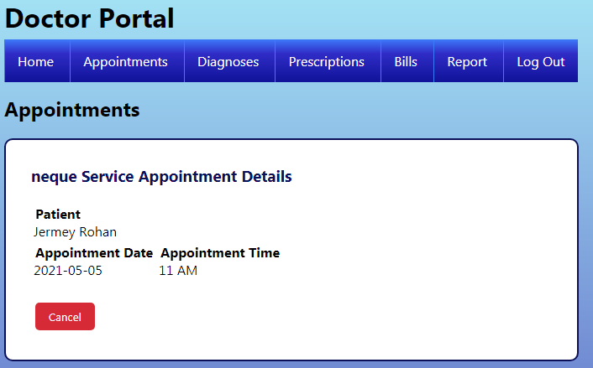

The Diagnoses tab allows a doctor to view the diagnoses of any patient, as well as add to them. If the doctor wants to look up a diagnosis for a patient, all he has to do is select the patient in the dropdown and press “View Details”. This will list out that patient’s diagnoses. The doctor can also add a diagnosis by selecting the patient, selecting the diagnosis, and leaving a note with details about why this was diagnosed and perhaps details about recommended treatment. Press the “Diagnosis” button and your details will be added, along with today’s date.

*The Diagnoses tab of the doctor portal*

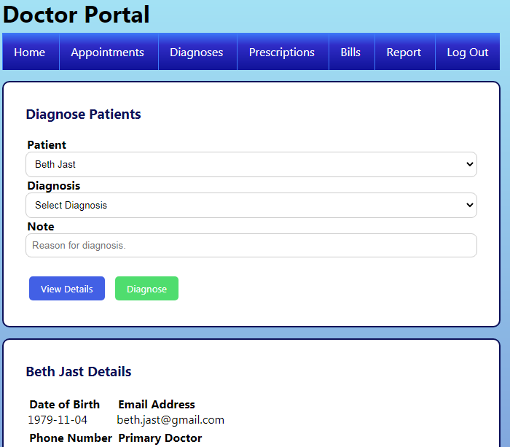

The Prescriptions tab allows a doctor to view and write prescriptions for any given patient. Similar to the Diagnoses tab, you can view a patient by selecting a patient from the dropdown and pressing “View Details”. This will display the prescription information for that patient. You can also add a patient by selecting a patient and the appropriate prescription. Enter a doctor’s note about the prescription if you wish, which may include instructions, dosages, reason for the prescription, etc. and then press the “Prescribe” button. This will add the prescription to the patient’s record and stamp it with today’s date.

*The Prescriptions tab of the doctor portal*

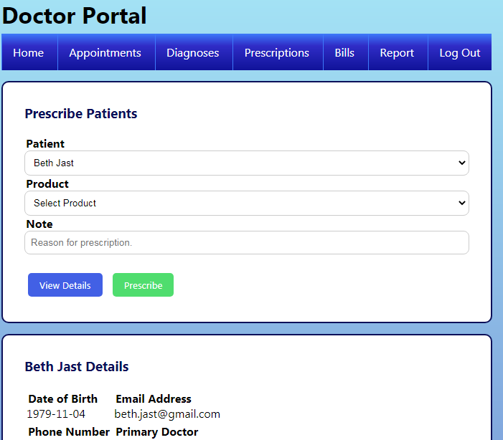

The Bills tab allows the doctor to view and manage bills for a given patient. Similar to the Diagnoses and Prescriptions tabs, you can view a patient’s existing bills by selecting a patient from the dropdown and pressing “View Details”. You can create a new bill for the patient by selecting the patient, selecting a service to bill for, and assigning a due date for the bill to be paid by. Once the information has been entered, press “Bill” and the bill will be viewable and payable from the patient portal.

*The Bills tab of the doctor portal*

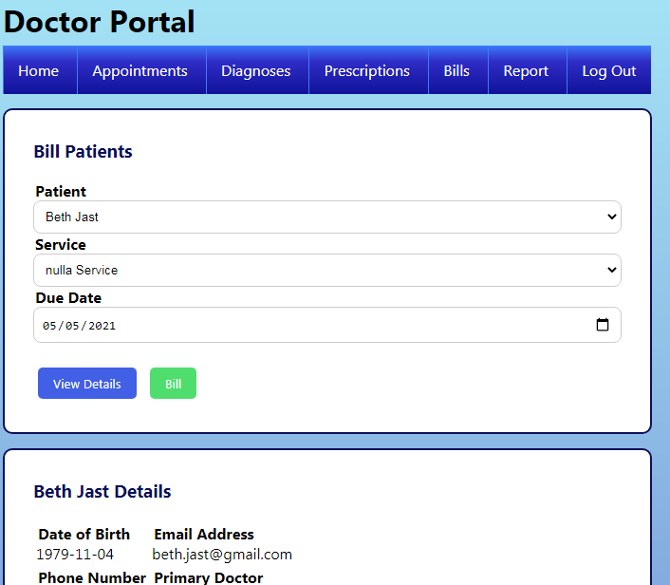

The Report tab is the tab to use when you are not sure who a patient is and what their details are. From here you can select any patient and press “View”. This will give you a synopsis of the entire patient, including account information, insurance, appointments, diagnoses, prescriptions, and bills.

*The Report tab of the doctor portal*

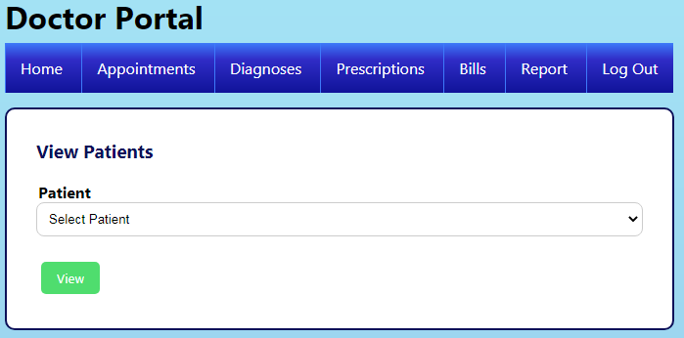

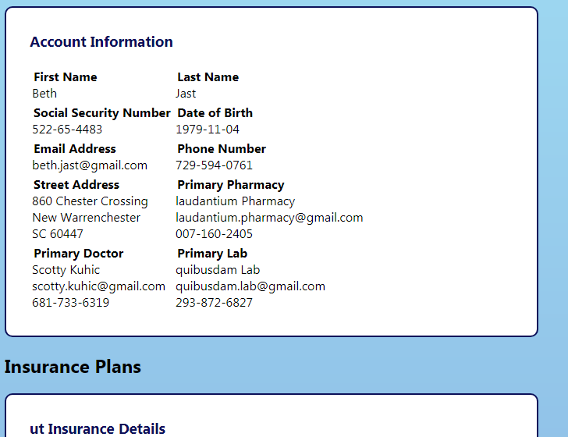

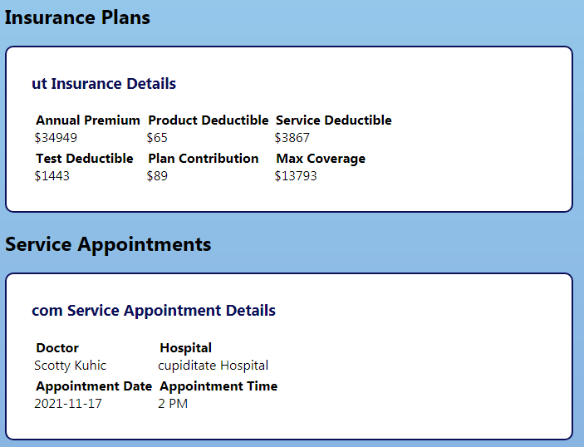

*The report tab features even more information, including diagnoses, prescriptions, and bills for the patient.*

# 8. Future Improvements

There are a few ways to improve the MyHealth portal that we could implement with more time, more money, and more staff. I think the first concern we would address is with the doctor portal, in which selecting a patient involves choosing their name from a list of dropdown options. This could cause an issue finding the patient you are looking for if there are too many patients in the database, and cause another issue if there are two patients with the same name. An improved implementation could perhaps be made where you can search for a patient using several different criteria and select the patient from a detailed list of results. You could also make the doctor portal more powerful by implementing some way of having doctor “visits” in which a patient would come in and you could take down health information, such as weight and blood pressure, and you could bill for things and keep records on a per-visit basis. This is a huge task, however, and would take several months to implement well. Another idea for improving the patient portal could be to allow the patient to see what time slots are available for scheduling appointments. This is another huge task and would require us to implement algorithms for discovering those time slots. In addition, some doctors will see more than one patient in different rooms at a given time slot, and so you would need to take that into consideration as well. If we had the time and the manpower, though, it could certainly make the application stronger.

# 9. Conclusion

The MyHealth Portal is a reasonably powerful tool for both patients and doctors to use. The central database allows both patients and doctors to interact with the same set of up-to-date information. Meanwhile, the friendly web interface allows those who are unfamiliar with technology to update the database with new information. Doctors would be able to use this application to keep records of what they have diagnosed, prescribed, and done. Patients would be able to review this information in real time. The goal of the MyHealth portal is to enable sharing and managing of information between both doctors and patients, and at this it succeeds. Our code is available at <https://github.com/zand8959/MyHealth-Patient-Portal> for you to download and experiment with. Or, if you would like access to additional features for use with the pharmacy and laboratory applications, you can download source code from <https://github.com/huntercasteel/MyHealth-Portal>.